Chapter 5

The Landscape of Parliamentary Enclosure

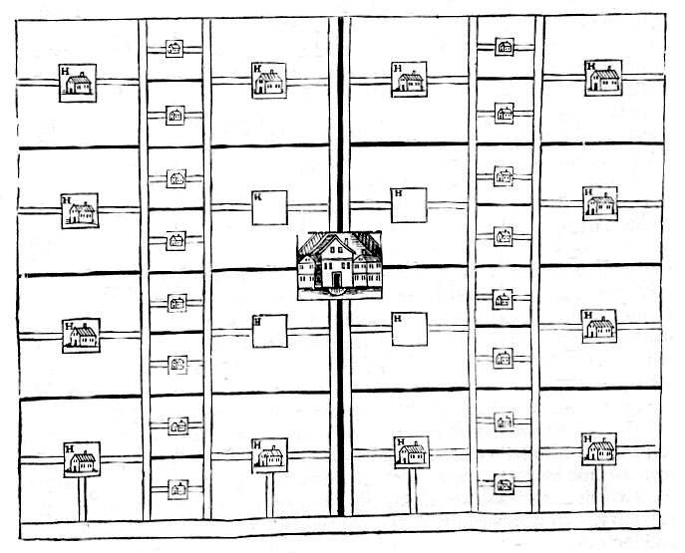
What would an ideal enclosed landscape look like? This question had occupied agricultural writers and theorists for centuries. The location and nature of the parish had a major influence on how near the ideal an enclosure could be. In 1653, for example, an idealised plan for an estate contained square holdings of mixed sizes conveniently arranged for access and draining and for the economically efficient provision of fencing and labour (see fig. 5.1). There were many advantages to such a layout. Each farm was compact with the homestead conveniently located at its centre. The square units were economical to fence and to drain. Each of the larger farms was able to draw on the labour of the neighbouring smallholders. This scheme had several important disadvantages. It would have necessitated considerable expenditure on new buildings. More importantly, it was only suitable for a parish where there was uniformity of soil. In a parish of mixed soils land of different qualities was best suited to different uses – land near a river or stream was often used for meadow, arable land was that which was both fertile and readily ploughed throughout the year, the waste was often of little use for more than rough grazing. Other descriptions of the ideal layout of a parish envisioned enclosure taking the form of concentric rings radiating out from the village in the centre and including areas of arable, meadow, and pasture. Again, this ideal was rarely possible. Henry Homer believed this was the ‘best Method which could be devised, both for Beauty and Convenience, as well as Cheapness.’ For the long narrow parishes typical of the downs a more pragmatic solution was necessary. These parishes were well suited to the scattered fields of open field, communal agriculture. In the four parishes with heavy clayland meadows in the north, fertile loam farmed as arable in the centre, and light, unimproved downland in the south, this was especially true. A holding of scattered strips could easily contain portions of each. An enclosed farm containing one compact piece of land could not. On the other hand Thomas Stone, another of those commissioned by the Board of Agriculture to write a general view of a county’s agriculture (i.e. Lincolnshire) noted that’ the more square the allotments are made, and the more central the buildings are placed, the more advantages are derived to the proprietors in every respect. The task of the enclosure commissioners was, in essence, to create a landscape of allotments that came as near as possible to these ideals. For the long narrow parishes extending from the Vale of the White Horse up to the Berkshire Downs this remit was difficult to meet. Figure 5.2 is an extract of Ardington Meadow from a working map of the enclosure commissioners at Ardington. It provides an insight into some of the principles followed by John Davis, George Barnes, and the others as they enclosed. Access to the allotments was to be by two newly created straight private roads. As much as possible, the allotments were then made to border the road in neat and economically efficient rectangular fields. The organisation of the old common meadowland was largely disregarded. Often however, the commissioners and their surveyors did not start with blank sheet. Some features of the old landscape remained unchanged. When they were not amalgamated with new enclosures as a result of the parliamentary award, haphazard piecemeal enclosures remained and are often easily identifiable by their size and shape. The three fields known as Barwell Closes at the bottom centre of fig. 5.3 are typical of piecemeal enclosure of single reversed S-shaped lands in the old arable field. Many of the pre-enclosure roads were hedged but otherwise left to run in their original paths. The main roads shown on the map through the village of Grove remained unaltered at enclosure. West of the village (at the bottom of the map in fig. 5.3) is a road that followed the boundaries of the old enclosed fields until it reached the newly allotted land. It is often possible to identify the location and shape of the old open fields simply by locating the gentle S-shaped bend of an old strip in the layout of a road or field.
Fig. 5.1 The idealised enclosure landscape as envisioned by Dymock in the seventeenth century. Fencing, drainage and road making were economical and the location of smallholdings close to the larger farms provided convenient labour. However, it necessitated building new farms on each holding and it would not suit the long narrow parishes in the Wantage area with the wide variation of soils.
Source: Dymock, 1653
Fig. 5.2 Working Enclosure Map of Ardington This extract from the parish shows several features of the newly created landscape. The road is Ardington Lane, a private road providing access to the allotments in Ardington Med. The allotments show no regard for the original layout of the common meadow. William Wiseman Clarke has been allocated a large allotment in the meadow. Beside it is the Middle Common, again allocated to Clarke and to the far right are several earlier enclosed fields. The ‘T’ marks along the boundaries indicate who has responsibility for planting and maintaining the hedge.
Source: BRO D/EL P1
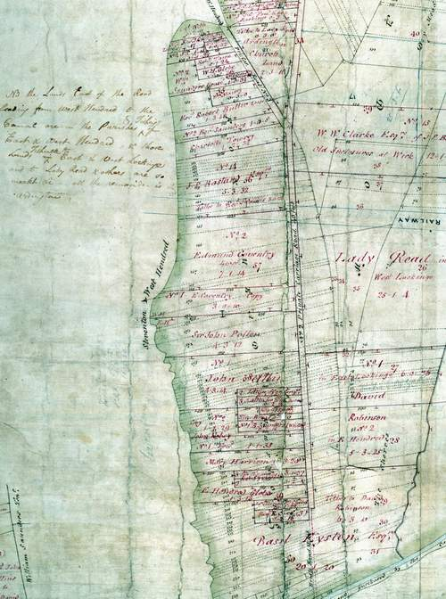

The Roads and Canal
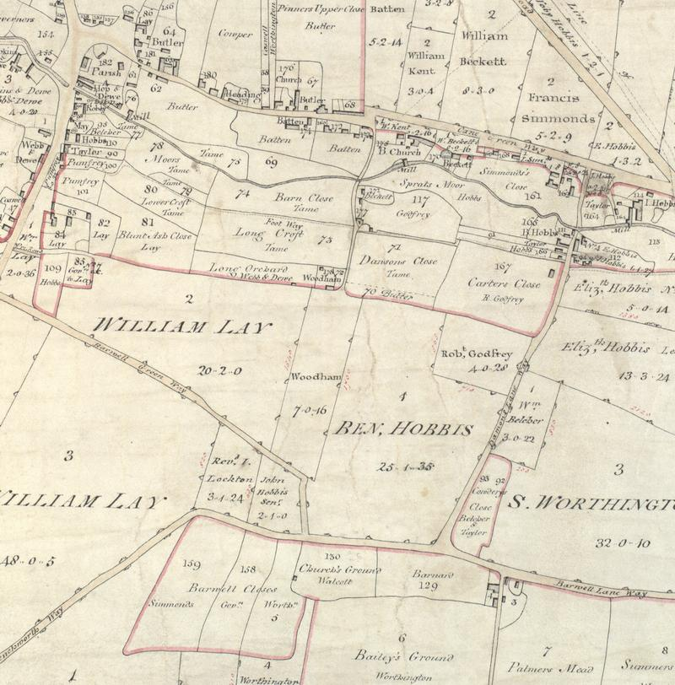
The first feature that the enclosure commissioners laid down was the network of public and private carriageways, highways, driftways, bridleways, and footpaths. These became the structure around which the rest of the new landscape was built. The road pattern before parliamentary enclosure had developed organically. Even in areas of earlier, non-parliamentary enclosure the road network was more haphazard than that created by the commissioners. During the period of parliamentary enclosure in England an essentially new road system had been created. The major routes through a parish were, by the early nineteenth century, often turnpikes. There were three in the Wantage area, the turnpikes running from London to Newbury and on to Swindon, from Challow to Faringdon, and from Wantage to Hungerford. These were owned by turnpike trusts and their regulation was outside the jurisdiction of the parish. They were specifically excluded from the remit of the enclosure commissioners. Apart from the London to Newbury Turnpike, there were two main routes running east to west through the area. Furthest south was the ancient pathway known as the Ridgeway which passed through Letcombe Regis, Wantage, East Lockinge, and Ardington. At sixty feet from hedge to hedge the road was consistently the widest public road, apart from the turnpikes, in the parish. The awards for West Challow, Letcombe Regis and East Challow, and Ardington specify that the road was, according to the awards, to remain in its ‘present course’. Thus its modern course appears to be pretty much unaltered. The width of the road is reminiscent of earlier parliamentary enclosures where sixty feet was a standard width for most major routes. By the early nineteenth century this had been reduced to forty feet. It is possible that the use of the Ridgeway as a droveway across the downs was a deciding factor in its width. The other main route across the parishes was the Ickleton Road. It, like other well-travelled routes in the area, was forty feet wide and apart form being hedged, was left with little alteration at enclosure. Less important roads were between twenty and thirty feet from hedge to hedge. Bridleways were usually ten to fifteen feet wide and footpaths six. All were to be embanked and fenced within six months of the awards made under the 1801 General Act and twelve months at East Lockinge and Charlton under the General Inclosure Act of 1845.
Fig. 5.3 Fossilised features in the Grove landscapes are illustrated in this extract (orientated approximately east-west top to bottom) from the enclosure map. The small fields with no areas are old enclosures that were left unaltered by the enclosure commissioners. The location of these earlier features partially determined the shape and layout of the new allocations.
Source: BRO DP 143 26C

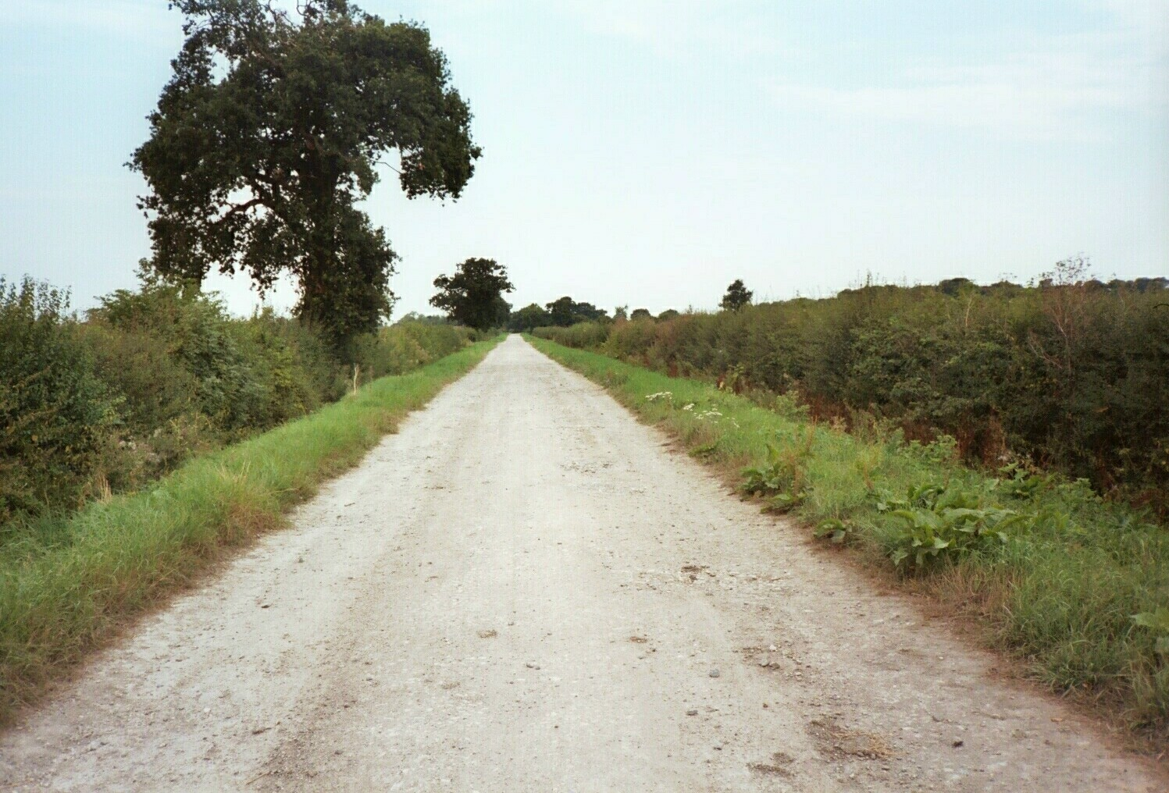
Routes between villages before enclosure were often little more than pathways that meandered across the open fields along the meers, balks, and headlands. Because there was no systematic planning, parishes had more roads than needed. One of the principal tasks of the enclosure commissioner was to rationalise this network. The old roads, bridleways, and footpaths were straightened, widened, closed off, or even left pretty much in their original state. New roads and paths were laid out. At Furzwick, on the downs above Wantage, the crossroad where the Ridgeway and Court Hill Road cross Manor Road was, before 1806, a junction of the Faringdon Road, the Lambourn Road, the Hungerford Road, and the Newbury Road. Just south of there the London Road, also called The Ridgeway branched off the Hungerford Road and met the Newbury road just slightly further east (fig. 3.5). Similar rationalisation of the roads occurred everywhere in the area. Public roads often either followed along parish, field, or furlong boundaries, or along the track of an older road, bridleway, or footpath. This has resulted in sharp right-angled bends where at the edges of ancient furlongs and gently bending roads following the backwards S-shape of the long sides of the strips. Where practical, the roads were straight. Many were a mixture. Upper Field Road in Ardington, for example was to be 40 feet wide and travel from ‘Ardington at the Bridge westward for about 100 yards and then southwards into Ilkeston way and thence eastward along the Ilkeston way to the entrance of the present road or way leading over lands in Betterton and from the last mentioned Road over lands in Betterton at the northwest corner of Newbury Way Furlong into the Lockinge and Ginge road.’ The Lockinge and Ginge Road was again 40 feet wide and went out of hamlet of Betterton in or near its present track into the hamlet of Ginge.

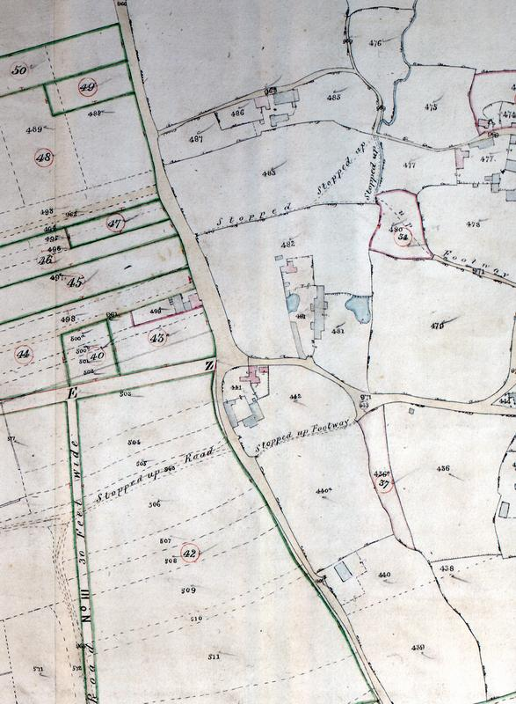
Ardington Lane is a typical enclosure road (see fig. 5.4). Today it is a bridleway and looks very much as it would have at the time of enclosure. This road, ‘Private Carriageway No. 2’ was to be 40 feet wide with hedges and ditches on either side. According to the award, its track was to go ‘out of the Turnpike Road opposite Lower Field Road in the track of a former road to the meer usually called the Church Meer and along the said meer eastward for about 130 yards and then northwards over Bank Hedge Furlong to Whistler’s Corner and from there to the corner of the homesteads called Mallams and over Ardington Meadow to the entrance into the third allotment of the Rev Richard Coxe lessee of the Lambourn Almshouses’. The width of the road included the verges on either side to provide alternative routes along the road in times of bad weather and when the road was particularly worn. This was essential until the improvements in road surfacing that were introduced by men like John Metcalf and J.L. Macadam in the late eighteenth century, were more widely adopted in the second quarter of the nineteenth century. Until then, the roads remained medieval in form but, through far greater traffic, were in a much worse condition. Roads on both the chalks and the clays could become almost impassable during a wet season. The verge also provided feed for livestock. Where needed to help drainage, the ditches along the side of the roads in Ardington were to be four foot wide and two deep. These were essential along ‘Private Carriageway No. 2’ which ran through the heavy clays of Ardington Meadow. This road, because it was used for access to private land, was funded, hedged, and maintained by the people using it for access. The right to feed the verge of the private roads belonged the person responsible for maintaining that section of road. Public roads, but not always footpaths and bridleways, were built and maintained by the parish. In an effort to reduce costs of the enclosure as much as possible, enclosure roads were often straight and therefore shorter. This principle was often followed for making private roads since they tended to cut across a number of newly created holdings.
Fig. 5.4 Ardington Lane, Ardington is a typical enclosure road, looking more as it would have in the nineteenth century because today it is a bridleway and chalked. The road is 40 feet wide, ditched and hedged on both side and almost completely straight. The road with its verges was wide enough to allow various paths through when the road was wet and muddy.

One manifestation of the changing attitude towards the land as property at enclosure with a visible impact on the landscape was the increased sense of ownership and with it a stronger notion of trespass. This found expression in the landscape in the newly created road network. In Letcombe Regis and the Challows, Wantage, Grove and Charlton, East Lockinge, and Ardington the enclosure commissioners created many public, and more significantly in terms of this increased sense of ownership, private roads and ways (see fig. 5.5). In the open fields access was simple. There were footpaths and bridleways marking the main routes across the arable fields and the meadows. In addition the fields were criss-crossed with meers and balks which gave access to the strips in the field. Entrance into the commons and wastes was even less restricted. When the fields were in strips and grazing communal, there was very little emphasis placed on trespass. At enclosure this changed. The consolidation of holdings into individual allotments did away with the meers and balks and many of the footpaths and roads. New private roads were needed to replace the open access across the fields and allow admission to each individual holding.
Fig. 5.5 One of the important changes affecting the landscape was brought about by the rationalisation of the road network. Before enclosure the road system had grown organically. The result was many routs that were convenient but not essential. The extract taken from the enclosure map of Charlton shows some of the steps taken by the commissioners as they closed old routes and created new ones.
Source: BRO Q/RDC 67B

Where it was to pass through the area, the enclosure commissioners were also responsible for allotting land for the building of the Wilts and Berks Canal. The canal, its towpaths, and the land needed for wharfs took precedence over other allocations in the hamlet of Grove. A forty-foot wide strip of land on either side of the proposed canal was allocated the canal company. The award noted that the owners of the land were to be compensated for its loss.

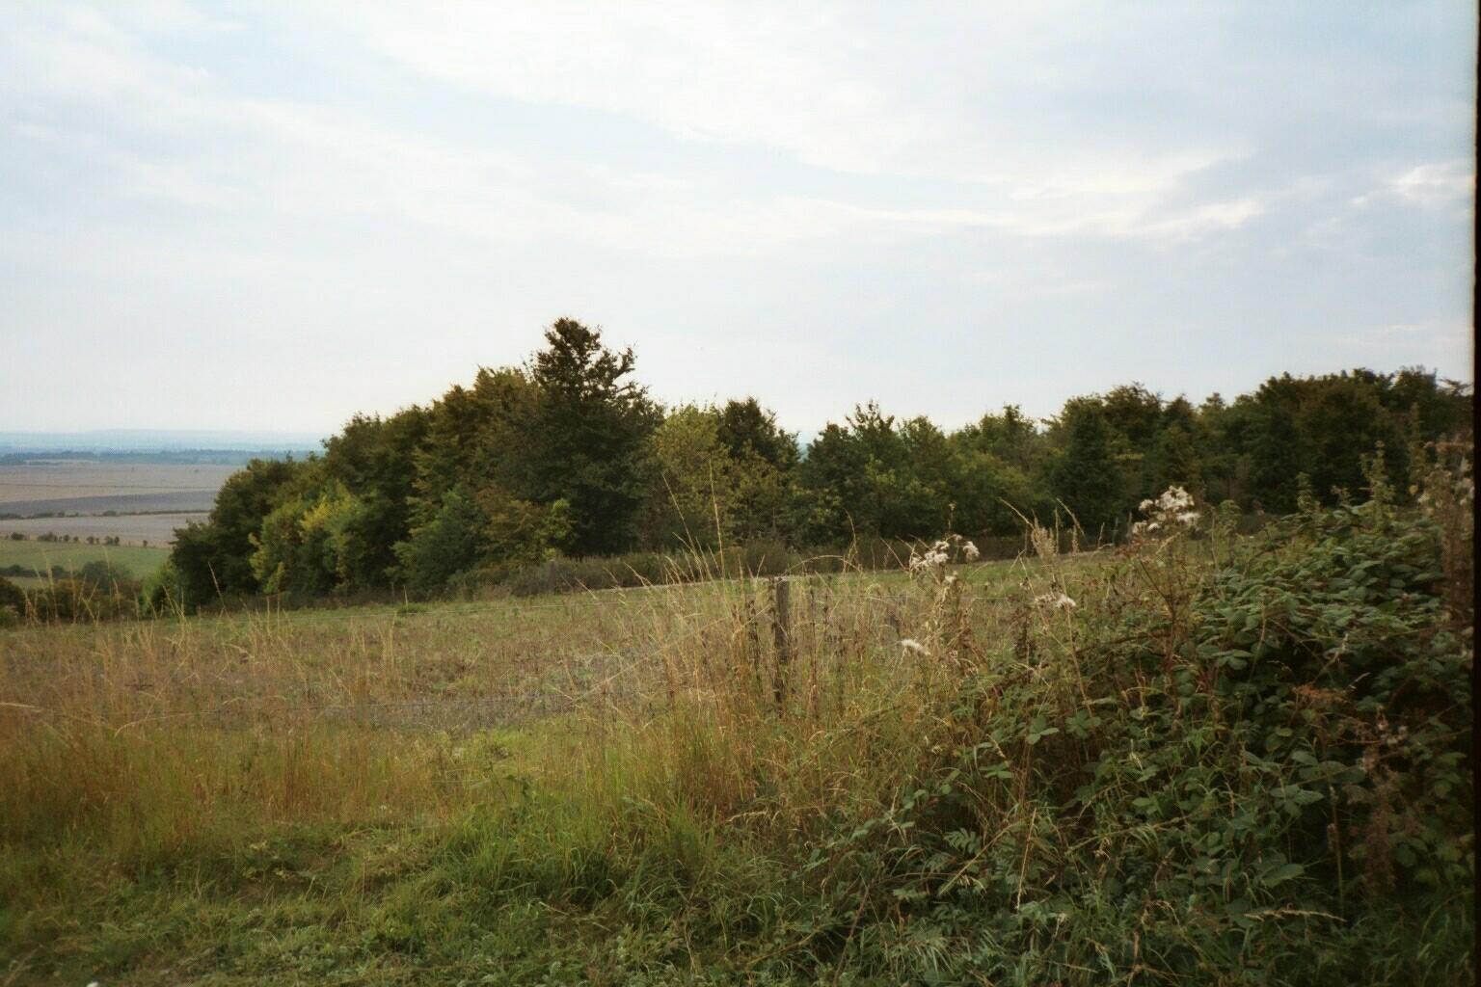
The need to build and maintain roads created another feature of the enclosure landscape, the gravel or chalk pit. Each award allotted land for this purpose. These were generally small and, because chalk was used for road building, they were often located on the downs. The one chalk pit in East Lockinge was three-quarters of an acre. In Ardington one pit of three-quarters of an acre was allotted on Wether Down. The provision for pits at Letcombe Regis was more generous. Two allotments, one of 3 acres 10 perches and a second of 1 rood 24 perches, were set aside for road repair. In Wantage there were three chalk pits located just of the Ridgeway on the down. One was just over a third of an acre, the second was 1⅔ acre, and the third, 2 acres. The hamlet of Grove had no downland and therefore no source of chalk. The half-acre set aside for road maintenance was a gravel pit. The land around the pits was to be let out at the best rent obtainable and the income supplemented the funds used by the highway surveyor to maintain the roads. Today the chalk and gravel pits are often no longer used for road materials but instead have filled with water or are overgrown with trees and bushes to become nature reserves (fig. 5.6). On some occasions they have been reclaimed and, with uncertain legality, used for agriculture.
Fig. 5.6 This chalk pit, the largest of the three in Wantage, was established to provide chalk for road building and maintenance. Today it is tree filled and has become something of a nature refuge.

Allotments and Farms
Once the road network was complete, the land could be divided and allocated. Wherever possible the enclosure commissioners were expected to create a single, consolidated holding containing an area of meadow, arable, and pastureland conveniently located adjacent to the dwelling and the enclosed ground around it. Because of the variation in soil in the four long and narrow parishes around Wantage, this was rarely possible. In spite of this, in addition to their homesteads, most claimants were awarded single parcels. Of the proprietors in Letcombe Regis and East Challow, thirty-three received a single allocation of land. Twenty-one were meadow, eleven in the arable fields, and only one – the Dean and Chapter of Winchester and
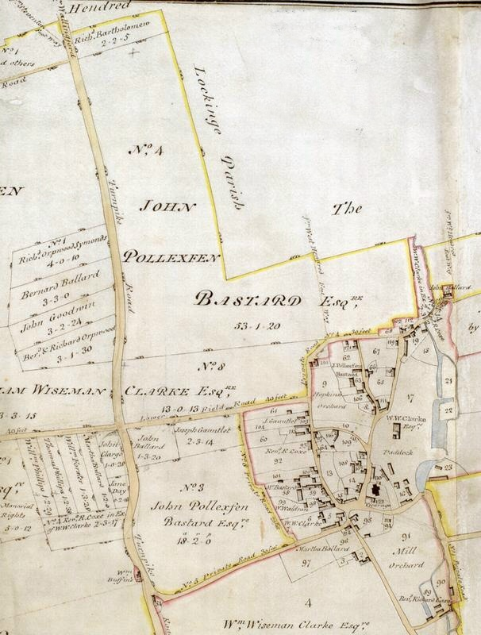
Thomas Goodlake their Lessee - on the downs. A further eighteen owners were allocated land in two blocks, six in three, five in four, and nine in five or more blocks. John Harley Drummond received thirteen allocations with a total of slightly over 121 acres. At Ardington thirty-one owners were given a single allocation in addition to their homestead. The majority of these were allocations of meadowland away from the village. Of the allotments for arable
Fig 5.6 Although the enclosure commissioners could reduce the movement of farms out of the village by allocating land in single blocks adjacent to the homestead of the claimant, they were not compelled to do this as is shown in the extract from the Ardington award where the awards to the largest owners took precedence.

Yelling, 120-3, 134-8
Dymock, 9-10
Homer, 90-1
Stone, 42-3
Turner, 1984, 147; Talyor, 1979, 172
Taylor, 1979, 172
Boulter, 68-9
Information supplied by M.E. Turner and John Chapman
BRO Q/RDC 21A; Q/RDC 89A; Q/RDC 82A; Q/RDC 67A
Turner, 1984, 149-50; Emery, 142; Hoskins, 1967a, 98
Taylor, 1979, 160-1
Hoskins, 1967a 98,
BRO Q/RDC 67A
BRO Q/RDC 21A; Q/RDC 89A; Q/RDC 82A; Q/RDC 67A
Turner, 1984, 158
BRO Q/RDC 82A

